AI Assistant for HR: project hand-off
Employee onboarding app with an AI Assistant · Sprint 3 · 21 October 2026 · Dev 1, Minh Quang Tran
Branch: merge/sprint3-details-chatbot (chatbot work merged with Nihal's Sprint 3 details/help work). Repo: Minarsh1520/garage-boilerplate-basic.

Overview
Next.js 16 (TypeScript) on Firebase: Firebase Auth for sign-in, Firestore for data, Google Gemini for the AI. All database reads and writes go through the server (Admin SDK); the browser is blocked by Firestore rules. Paths below are under frontend/src/ unless shown.
Step | Command (from the repo root)
Install | pnpm install
Settings | Fill the root .env (see docs/ENV-VARS.md), then pnpm run env:sync
Demo data | pnpm --filter frontend exec tsx --env-file=../.env scripts/seed-rag.ts (add --reset to reset demo employees)
Run | pnpm dev
Tests | pnpm --filter frontend test and pnpm --filter frontend typecheck

Demo logins (password in DEMO_USER_PASSWORD): alex.chen@northbridge.example (tasks pending), jordan.taylor@northbridge.example (all done), hr.admin@northbridge.example (admin).

4.3 Non-functional requirements
As built. Draft for review with Nihal (Dev 2) and Scarlett (BA), with Arman (UI/UX) for usability and accessibility. The Target column is what to confirm.
Area | As built | Target to confirm
Security | All data reads and writes on the server; session checked on every action; admin role checked on every admin page and action; Firestore rules block browsers. | Penetration test or security review before real data
Privacy | Employees see only their own record, conversations and cases; the AI gets only the fields it needs; error details stay in server logs. | Paid Gemini plan; how long conversations are kept
Reliability | Several Gemini keys with model fallback and retries; error codes; nothing reports success unless the save worked. | Acceptable downtime when Gemini is unavailable
Performance | One AI call per question; stored answers need none; 15 s limit per AI call; "taking longer" message after 8 s. | Typical answer time (e.g. under 10 s)
Usability and accessibility | Plain-language replies; preview and Confirm before any change; app tour; screen-reader announcements for new messages; one colour and font pattern. | Accessibility check (contrast, keyboard use) with Arman
Compatibility | Built for current desktop browsers; layouts are responsive. | Phone testing
Maintainability | TypeScript, input validation with Zod, limits kept as named constants, 170 unit tests. | Test coverage expected before release
Cost | Runs on free tiers (Firebase, Gemini). | Monthly budget for the paid plan

5.1 System context diagram
Who uses the system and which outside services it depends on.
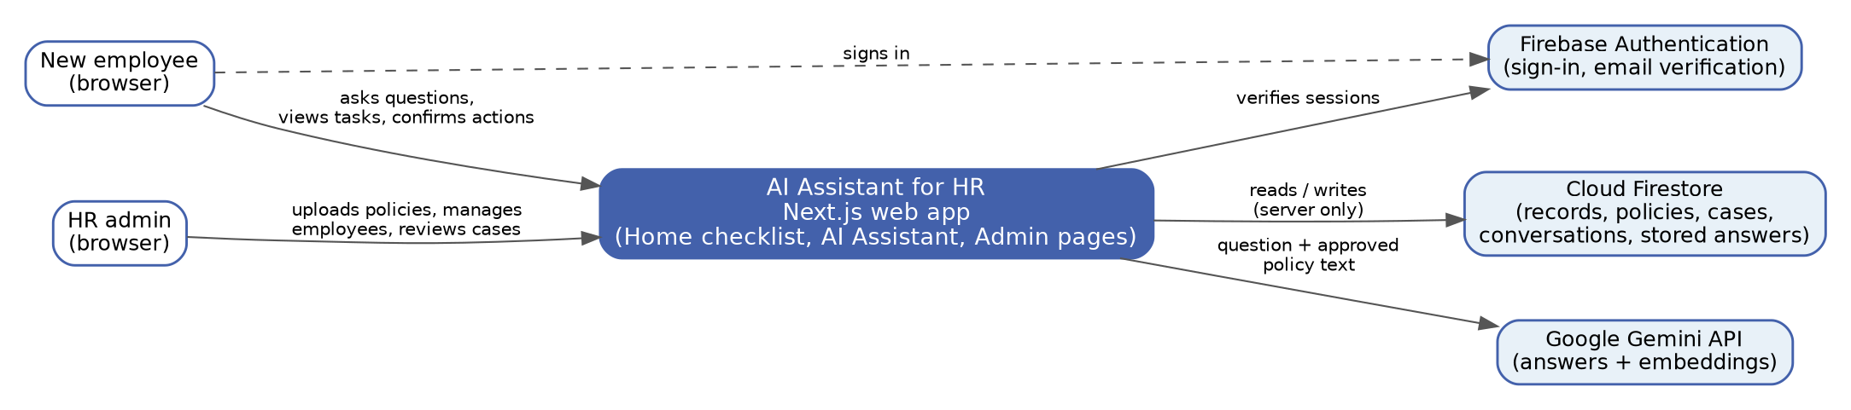
Figure 1. System context

5.2 Architecture overview (as built)
Next.js 16 (TypeScript). The browser only renders pages and calls Server Actions; every rule and database call runs on the server with the Firebase Admin SDK. Gemini is reached only through the key pool.
Layers
Every request goes through a Server Action, which checks who is asking before any feature code runs.
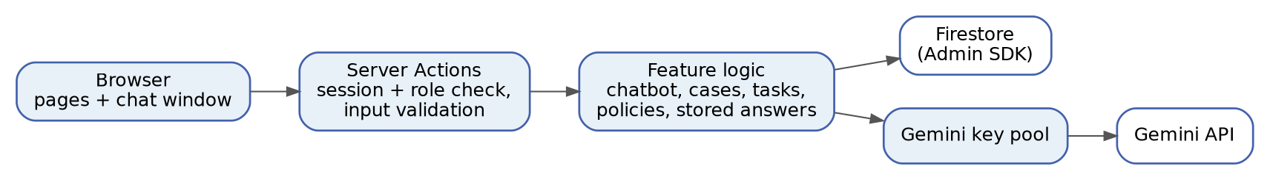
Figure 2. Request layers
Answering a question
Cheap checks first; at most one Gemini call; code, not the AI, decides the reply.
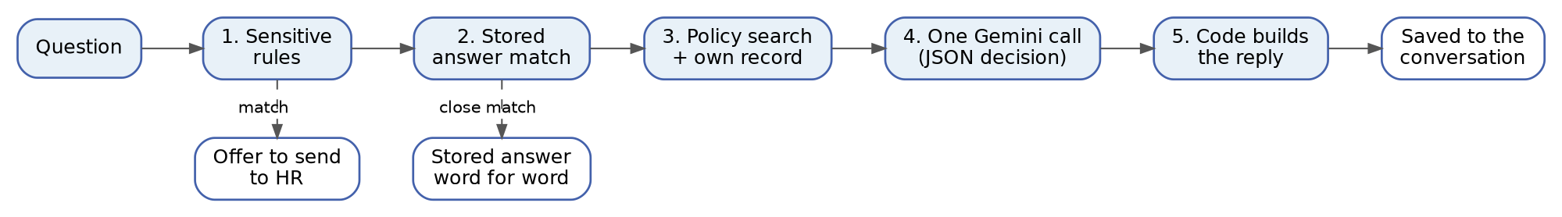
Figure 3. Chatbot pipeline
Publishing a policy
Every file type is turned into lines and checked by the same layout reader.
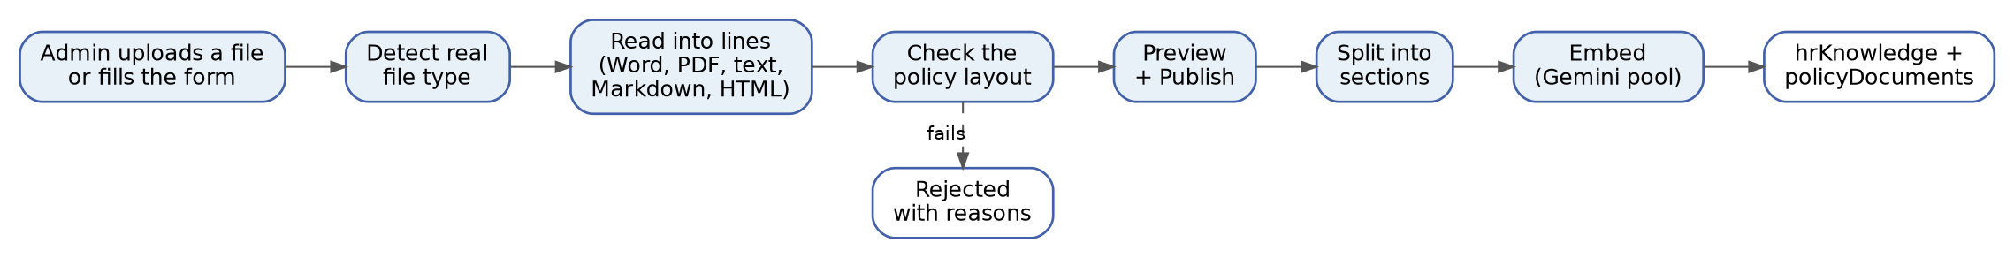
Figure 4. Policy publishing
Actions that change data
Sending a case or marking a task done always follows preview, Confirm, server re-check.
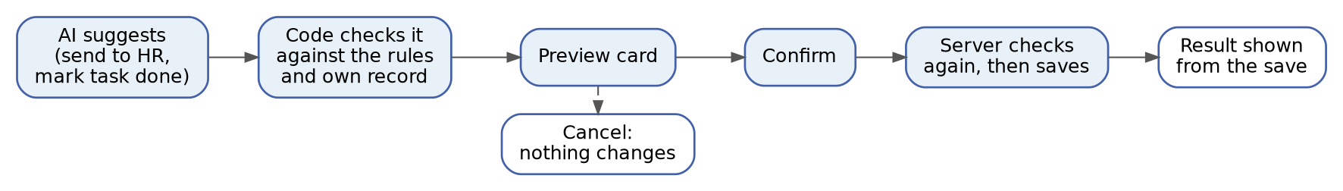
Figure 5. Preview and confirm
The optional backend/ folder (Express on Firebase Functions, health and notes routes) is boilerplate and not used by these features.

Features and files
1. Sign-in, roles and navigation
Email/Google sign-in with verified email, a 14-day server session, and an Admin area for users with the admin role.
File | How it works / contributes
providers/AuthProvider.tsx, lib/firebase/* | Firebase sign-in in the browser; on sign-in it also claims a pre-added employee record (see 10).
app/api/auth/session/route.ts | Swaps the Firebase token for a 14-day session cookie; DELETE signs out.
actions/auth.actions.ts | requireAuth / requireAdmin check the session on the server; admin = users/{uid}.role is admin.
proxy.ts | Quick cookie check that redirects signed-out users away from protected pages.
app/(auth)/auth/signin, signup, app/page.tsx | Sign-in, sign-up and landing pages.
components/layout/Sidebar.tsx, Navbar.tsx, AdminSidebar.tsx, DashboardShell.tsx | Navigation; the Admin link only shows for admins.

2. Home: onboarding checklist
Shows the employee's own tasks, status and due dates, with a detail popup per task.
File | How it works / contributes
app/(dashboard)/dashboard/page.tsx | Reads the signed-in employee's record and lists the checklist.
components/onboarding/TaskCard.tsx | One task row with a "View" popup (details, status, due date).
lib/onboarding.ts | Shape of employeeData/{uid} (details + checklist), shared with the chatbot.
app/(dashboard)/profile/page.tsx | Employee profile page.

3. Help menu and app tour
A guided tour of Home and the Assistant, replayable from "Help".
File | How it works / contributes
components/layout/AppTour.tsx | Step-by-step tour; highlights elements by their data-tour names.
components/HelpMenu.tsx | Replays the tour for the whole app, Home or the Assistant.

4. AI Assistant: answering questions
Answers from approved policies and the employee's own record only; never invents.
File | How it works / contributes
features/chatbot/lib/pipeline.ts | The question flow: sensitive rules → stored answer → policy search + own record → one Gemini call → code decides the reply.
features/chatbot/lib/rules.ts | Sensitive words (complaints, pay, dismissal, leave approval, payroll changes) go to a person with no AI call.
features/chatbot/lib/decision.ts | System prompt and JSON answer format: answer, clarify, not found, record unavailable, off topic, escalate.
features/chatbot/lib/record.ts | Reads only the signed-in employee's record and formats it for the AI.
lib/rag/embed.ts, retrieve.ts, faq.ts | Turns the question into a vector and finds the closest policy sections and stored answers.
features/chatbot/lib/errors.ts, lib/rag/retry.ts | Error codes (e.g. AI-429, DB-SEARCH) and short retries when Gemini is busy.
features/chatbot/components/ChatWindow.tsx | The chat screen: thinking indicator, Stop, previews, links, "Get a more detailed answer".
features/chatbot/actions/chatbot.actions.ts | Server entry point sendChatMessage: checks the user and input, then calls the pipeline.

5. Saved conversations
History kept on the server, listed in a dropdown, reopened after leaving the page.
File | How it works / contributes
features/chatbot/lib/conversations.ts | Saves each question and answer in one batch; lists, renames and deletes, owner only.
features/chatbot/components/ConversationPicker.tsx | The conversation dropdown: switch, rename, delete, New chat.
features/chatbot/actions/conversation.actions.ts | Server actions for the list and the optional summary.
features/chatbot/lib/follow-up.ts | Spots follow-ups ("and for part-timers?") so the search keeps the topic.
features/chatbot/lib/summary.ts | Optional summary: explained, previewed, saved only on approval.

6. Sending a matter to HR (cases)
The employee previews and confirms; a case is saved for the Admin Cases page.
File | How it works / contributes
features/chatbot/lib/escalation.ts | The only code that creates a case: repeat check, priority (High/Medium/Low), 3 non-urgent per 24 h.
features/chatbot/lib/case-titles.ts | Case headings and recipients, shared by the preview and the saved case.
app/(admin)/admin/cases/page.tsx, actions/escalation.actions.ts, lib/cases.ts | Admin list of cases, sorted High first, newest first.

7. Onboarding automation (BA rules)
The AI suggests; code checks; the employee confirms. Detail in "How the AI Assistant automates onboarding tasks".
File | How it works / contributes
features/chatbot/lib/due-dates.ts | Real due dates from the start date or saved dueDate, in Melbourne time; urgent tasks first.
features/chatbot/lib/task-completion.ts | "Mark task completed": own pending tasks only, re-checked in a transaction on Confirm.
features/chatbot/lib/pipeline.ts (PAGE_LINKS) | "Open my checklist" link; addresses come from code only.

8. Admin: policies
Admins upload or type policies; they are checked against one layout and published to the AI.
File | How it works / contributes
features/policy/components/PolicyManager.tsx, PolicyFormEditor.tsx | Upload (Word, PDF, text, Markdown, HTML) or fill in a form, preview, publish.
lib/rag/policy-file.ts, docx.ts, pdf.ts, html.ts, markdown.ts | Detect the real file type and turn each format into plain lines.
lib/rag/policy-sources.ts | The one layout reader: title, numbered sections; rejects with reasons.
lib/rag/chunker.ts, publish.ts, actions/policy.actions.ts | Split into sections, embed and save; a version number stops overwriting newer edits.

9. Admin: stored answers (FAQ)
Approved answers returned word for word before the AI, at no AI cost.
File | How it works / contributes
features/faq/components/FaqManager.tsx, app/(admin)/admin/faq/page.tsx | Add, edit, switch on/off, delete.
actions/faq.actions.ts, lib/rag/faq.ts | Save with an embedding; match only very close questions.

10. Admin: employees and tasks
Admins add employees before they sign up and assign tasks from templates.
File | How it works / contributes
app/(admin)/admin/employees/page.tsx | Employee list, add employee, assign or remove tasks.
actions/employee.actions.ts | Adds a pending employee (pendingEmployees); claimed into employeeData on first sign-in.
actions/task.actions.ts | Task templates, custom tasks, assign/remove; saves duein ("3 Days") and dueDate.
app/(admin)/admin/assistant/page.tsx | The Assistant inside the Admin area.

11. Shared look
One colour and font pattern on every page.
File | How it works / contributes
lib/theme.ts, app/globals.css | Blue #4361AB, text #222222, Arial; the dark-mode rule that faded text was removed.
components/layout/PageHeader.tsx, components/shared/* | Shared header, empty state, spinner and error boundary.

12. Data, scripts and docs
How the data is protected, seeded and documented.
File | How it works / contributes
firebase/firestore.rules (repo root) | Browsers can't read or write HR data; everything else is denied by default.
firebase/firestore.indexes.json (repo root) | Vector indexes for policy and stored-answer search.
frontend/scripts/seed-rag.ts | Demo policies, employees, admin login and starter answers.
frontend/scripts/probe-chat.ts, probe-rag.ts | Run the real pipeline / search on test questions (uses quota).
docs/FIRESTORE-SCHEMA.md, docs/ENV-VARS.md, docs/Sprint 3/* | Collections and fields, settings, and the Sprint 3 hand-off notes.
frontend/tests/unit/* | Unit tests with a fake AI and database (no quota needed).

5.4 Key technical decisions
Decision | Why
Server Actions + Admin SDK only; browsers blocked by Firestore rules | One place to check identity and permissions; the browser can't fake data.
RAG on Firestore vector search | No extra database; policies, stored answers and records live together.
One structured (JSON) Gemini call per question | Fits free-tier limits; code, not the AI's wording, decides what happens.
Sensitive rules and stored answers before the AI | Obvious HR matters go to a person and common questions cost nothing.
Gemini key pool with model fallback | Keeps answering when one key is used up or busy.
One policy layout and one reader for every file type | New file formats never need new reading code; bad files are rejected with reasons.
Preview and Confirm for every change | BA rule: the employee approves; the server re-checks before saving.
Conversations saved on the server | History across pages, and earlier answers the browser can't edit.
Dates, priorities and limits worked out in code | Predictable and unit-tested; the AI only explains results.
Filter and sort in code instead of composite indexes | Fewer indexes to deploy; lists per employee are small.

Background configuration

Gemini key pool
- lib/rag/gemini-pool.ts wraps one or more keys from GEMINI_API_KEY (comma-separated).
- Each answer tries the main model on every key, then GEMINI_FALLBACK_MODELS. A used-up key rests 60 s, a busy key 15 s, a bad key 10 min; an unknown model name is skipped.
- Each call has a 15-second limit. Embeddings switch keys only, never the model.
- Every key and model exhausted: the employee sees "busy, try again" (503) or "usage limit" (429).

Settings (environment)
Setting | Purpose
GEMINI_API_KEY | One or more Gemini keys, comma-separated (required)
GEMINI_MODEL | Answer model; default gemini-3.6-flash
GEMINI_FALLBACK_MODELS | Backup answer models, comma-separated (optional)
RAG_DISTANCE_THRESHOLD | How close a policy section must be; default 0.38
FAQ_DISTANCE_THRESHOLD | How close a stored answer must be; default 0.15
FIREBASE_SERVICE_ACCOUNT_KEY_BASE64 | Server access to Firebase (required)
DEMO_USER_PASSWORD | Password for the seeded demo logins

pnpm run env:sync copies only GEMINI_API_KEY and GEMINI_MODEL (plus Firebase values) into frontend/.env.local; the three optional settings must be added there by hand for now.

Chatbot settings (in code)
Setting | Value | Where
Question length | 2,000 characters | features/chatbot/types.ts
Embedding model / size | gemini-embedding-001, 768 | lib/rag/config.ts (changing it means re-seeding)
Earlier messages read per question | 6 (last 2 exchanges, answers cut to 400 chars) | conversations.ts, decision.ts
"Taking longer" message | after 8 s | ChatWindow.tsx
Summary offer / size | after 8 messages; max 1,200 chars | ChatWindow.tsx, summary.ts
Conversations listed | 50 newest | conversations.ts
HR cases | 3 non-urgent per 24 h; High never blocked | escalation.ts
Tasks an employee can't mark done | IT Account | task-completion.ts
Policy file size | 500 KB | policy.actions.ts
Time zone for "today" | Australia/Melbourne | due-dates.ts

Roles
- Employee: any signed-in, email-verified user; sees only their own record, conversations and cases.
- Admin: users/{uid}.role set to admin; checked on every admin page and action.

9.4 Known issues for the AI and backend
Issue | Detail
Depends on Gemini | No AI answers without quota or when Gemini is down (stored answers and sensitive rules still work). Free-tier limits are low; a busy Gemini can take up to 15 s per key.
Search thresholds unverified | 0.38 (policies) and 0.15 (stored answers) not yet tuned on real questions (probe-rag.ts).
Sensitive rules can over-match | e.g. "terminate my VPN session" goes to HR; the BA owns the word list.
AI judgement not tested live at scale | Unit tests use a fake AI; the prompt has only been checked by hand.
env:sync gaps | Optional settings (fallback models, thresholds) aren't synced from the root .env.
Backend folder unused | backend/ (Express on Firebase Functions) is boilerplate; all features run in Next.js.

Not implemented and limitations
Item | Detail
No way to create an admin in the app | Admins exist only by setting role: admin in Firestore or via the seed script.
Cases can't be closed | The Admin Cases page lists cases; there is no status update or reply.
IT and Manager pathways are labels | Every case goes to the HR Cases page; nothing is sent to IT or managers.
No email or notifications | Employees and HR aren't notified of cases or task changes.
Conversation retention undecided | Kept until the employee deletes them; no admin view.
Undo a completed task | Not possible from the Assistant; change it in Firestore.
Untested at scale | Not run with many users, on phones, or on the deployed site; screen behaviour is checked by hand only.
Open BA questions | Rule list wording, crisis wording, limit of 3, pay as High, who may mark tasks done.

